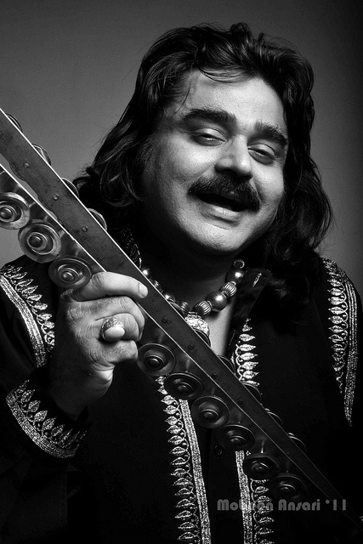Arif Lohar

Full Name:

 Arif Lohar Jugni

Date of Birth:

 1st-September 1966

Place of Birth:

 Gujrat, Punjab, Pakistan

Occupation:

 Singer, Actor, Songwrite

Personal Life:

Arif Lohar is known to be a private individual when it comes to his personal life. He is married to Sara Bharwana, and the couple has children. Arif Lohar contribution to the music industry, both in Pakistan and internationally, has earned him a dedicated fan following and established him as one of the leading voices in South Asian music.

Awards:

Arif Lohar has received numerous awards for his contributions to the music industry, including Lux Style Awards, Pakistan Media Awards, and Filmfare Awards (India).